Frequently Asked Question from Member States about the JRC (EASIN) data packages to support MS reporting under Art.24 of the Regulation 1143/2014

- Metadata

- Shall we submit a metadata file for species, which are not present in our territory?
If a species is not present, there is no need to report related metadata.

- Can we provide a single metadata for all the species?
Yes. A metadata file template per Member State (MS) is already available from https://easin.jrc.ec.europa.eu/easin/Services/Reporting to ease MS work.
The single species metadata files can also be used. In this case, the MS have to remove any reference to the specific species it refers.
In addition, the fields highlighted in grey must be changed with data relevant to the domain and data sources of the MS, as explained in the guidelines available at the following link: https://easin.jrc.ec.europa.eu/easin/services/reporting

As an example, you can find below a snapshot of the metadata package for Austria. The single metadata file is highlighted in grey.
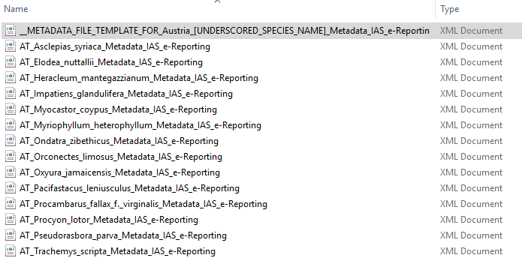

- Shall MS use and modify the metadata files provided per each species or fill the metadata template file?

The decision is up to the MS.

  - Which fields are mandatory to be changed/filled in the metadata file?

With reference to the guidelines downloadable at https://easin.jrc.ec.europa.eu/easin/services/reporting, the fields highlighted must be changed with data relevant to the domain and data sources of the Member State.

  - I cannot find all the fields listed in the Guidelines in the metadata files or template.
The metadata elements having a different name from that available in the xml, have been specified in the guidelines table. These elements and their specifications are:
      - Resource Type: gmd:MD_ScopeCodecodeList and
      - Conformity: please refer to elements gmd:DQ_DomainConsistency for both INSPIRE and Article 24 point 1 off Regulation 1143.2014 in IAS

- Where can I find the INSPIRE metadata editor?
The metadata editor was put temporarily offline due to security issues. Exactly the same products are available from the eEnvPlus project - http://eenvplus.sinergis.it/euosmegwt/. Alternatively, solutions like Geonetwork can be used.

- Shapefiles and Distribution Files (GML/GeoJSON)

  - Which attribute(s) should/must be provided along with the Shapefiles?
The Shapefiles were provided to support MS in the visualization of the species spatial data. Data values (attributes) are not included, partly due to limitations of this format in supporting data attributes, i.e. 1) field names maximum length is 8 character in Shapefiles, while the INSPIRE Species Distribution theme is much longer, 2) shapefiles do not support proper hierarchical data representation (XML/GML or GeoJSON like). If a MS is uploading a single, multilayer shapefile for all the species, then an “EASINcode” attribute needs to be added, and filled with the EASIN species id.
- How can I find the EASIN species identifiers (id)?
The EASIN species Identifiers are retrievable in two ways:
    - EASIN widgets at http://alien.jrc.ec.europa.eu/speciesmapper to search species by scientific name: once the species appears on the results, click on the (+) icon on the left of the species name to expand the data sheet. You will find the LSID, e.g. "urn:lsid:alien.jrc.ec.europa.eu:species:R07497:7.6" whereR07497 is the EASIN Species ID.
    - RESTful web services to search Species by scientific name, e.g. https://easin.jrc.ec.europa.eu/api/cat/term/Trachemys scripta troostii and look for the SpeciesCatalogueId value (in this case would be R19330).
In case taxa on MS national lists could not be found in the EASIN catalogue, please contact us. We will introduce the taxa in the EASIN catalogue and will assign to each species their unique identifier.

- Compilation of species distribution reports

  - Shall we use the species data packages provided by EASIN, edit them by adding/removing data (cells, and related data), or shall we use the GML/GEOJSON template file still provided by EASIN, and fill that file with the data we have?
This choice is left to MS. It is a matter of expertise, available tools, and also a matter of the number of records. Some might feel more comfortable in reusing the EASIN distribution files (GML or GEOJSON), while some others might reuse the EASIN template grid files as an example, to prepare/program some IT tool to generate output in that format.

- We already have our own INSPIRE compliant distribution files. We would like to reuse these files to avoid double work. Is it possible?
If they are compliant with the INSPIRE Species Distribution theme, yes. MS can also submit some test file, to let the EEA check if the files' format is correct.

  - Which data fields are mandatory in distribution files?

In general, fields referring to the species' name and MS name must always be provided. The EASIN DataSetId and SpeciesDistributionUnitId are provided with the GML files. MS have the option to keep such values, or to change them according to their needs. Both the SD files and the grid template, include the real EEA grid cell and their related cell id; MS must not change the cells longitude-latitude coordinates and/or the cells id in both the grid template and the EASIN SD files.

- Shall MS report the distribution of species who were detected and eradicated within the reporting timeframe (2015 - 2018)?
The answer is no. The guidelines state: The distribution map should provide information about the actual occurrences of the species (earlier observations of the species made before the reporting period could be included if there are reasons to assume that the species could still be observed in these areas). The distribution should be based on the surveillance system as provided for in Article 14(1) of Regulation 1143/2014 and any other source the Member State decides to use.
- We are preparing additional distribution files, for species not included in the EASIN data packages, and could not find GUIDs for some species in the EU-NOMEN system; could you please provide additional source for species GUIDs?
The INSPIRE SD theme foresee three different sources for species information, prioritized as follows: 1) EU-NOMEN, if the species is not present there 2) EUNIS, if not there 3) Natura 2000.

- Occurrences

- Do MS need to report occurrences?
It is not necessary to report single occurences. Darwin Core occurrence files are provided along with the EASIN packages to provide MS with the original vectorial species distribution from which the EEA standard grid distribution layer is then inferred.

